Mini Project – Expense Analytics
DATE:
EXP NO:8

AIM
To analyze and clean a large Expense Dataset using Python and Pandas, remove missing, invalid, and duplicate records, store the cleaned data in PostgreSQL/Supabase, and perform SQL-based expense analysis for visualization and dashboard creation.

ALGORITHM

Step 1: Install Required Libraries
- Install the required Python libraries for data processing and database connectivity.
- Use:
  - Pandas for data manipulation.
  - NumPy for numerical operations.
  - SQLAlchemy for database connectivity.
  - Psycopg2 for PostgreSQL connection.

Step 2: Import Libraries
- Import Pandas and NumPy.
- Import SQLAlchemy functions for creating and executing database queries.
- Import quote_plus for safely encoding the database password.

Step 3: Upload the Expense Dataset
- Upload the Expenses_clean.csv dataset into Google Colab.
- Store the uploaded file for further processing.

Step 4: Read the Dataset
- Read Expenses_clean.csv using Pandas.
- Store the dataset in a DataFrame named df.
- Display the dataset shape and first few records.
- Verify that the dataset has been loaded successfully.

Step 5: Check the Dataset Before Cleaning
- Display all column names.
- Check the data types of each column.
- Identify missing values using isnull().
- Identify duplicate records using duplicated().
- Use these checks to determine the cleaning operations required.

Step 6: Clean the Expense Dataset
- Create a copy of the original dataset named expense_clean.
- Remove unnecessary spaces and standardize column names.
- Remove completely empty rows.
- Convert the date_time column into datetime format.
- Convert the amount column into numeric format.
- Identify negative or invalid expense amounts.
- Replace invalid amounts with missing values.
- Fill missing amounts using the median expense value.
- Clean categorical fields such as:
  - Category
  - Account
  - Currency
- Replace missing tags with uncategorized.
- Remove duplicate records.
- Remove records having invalid or missing dates.

Step 7: Verify the Cleaned Dataset
- Display the number of rows remaining after cleaning.
- Check whether any missing values remain.
- Check whether duplicate records remain.
- Display the first few cleaned records.
- Verify that the dataset is ready for database storage.

Step 8: Save the Cleaned Dataset
- Save the cleaned DataFrame as expenses_cleaned.csv.
- Do not include the DataFrame index in the output file.
- Confirm that the cleaned dataset has been successfully saved.

Step 9: Connect to Supabase PostgreSQL
- Define the PostgreSQL username, password, host, port, and database.
- Create a SQLAlchemy database engine.
- Use quote_plus() to safely encode the database password.
- Establish a connection between Python and Supabase PostgreSQL.

Step 10: Test the Database Connection
- Connect to the PostgreSQL database.
- Execute the SQL command:
SELECT version();
- Display the PostgreSQL server version.
- Confirm that the database connection is successful.

Step 11: Store the Cleaned Dataset in PostgreSQL
- Upload the cleaned DataFrame to a PostgreSQL table named expenses.
- Use to_sql() to insert the data.
- Use chunks of 5000 records to efficiently handle a large dataset.
- Replace the existing table if it already exists.

Step 12: Verify Data Storage
- Execute a SQL query to count the number of records stored in the expenses table.
- Compare the database row count with the cleaned DataFrame.
- Confirm that the expense data has been successfully stored.

Step 13: Perform SQL-Based Expense Analysis
- Group the expense records according to category.
- Calculate the total spending for every category using SUM(amount).
- Round the total spending to two decimal places.
- Sort the categories in descending order of total spending.
- Display the resulting expense analysis using Pandas.

Step 14: Dashboard Preparation
- Use the cleaned PostgreSQL expense data as the source for a BI dashboard.
- Analyze important measures such as:
  - Total Spending
  - Spending by Category
  - Spending by Account
  - Spending by Currency
  - Spending Trend Over Time
- Connect the PostgreSQL/Supabase database to Power BI for interactive visualization.

COMPLETE PROGRAM CODE
!pip install pandas sqlalchemy psycopg2-binary

import pandas as pd
import numpy as np
from sqlalchemy import create_engine, text
from urllib.parse import quote_plus

from google.colab import files

uploaded = files.upload()

Expenses_clean.csv
df = pd.read_csv("Expenses_clean.csv")

print("Dataset shape:", df.shape)

display(df.head())

print("Column names:")
print(df.columns.tolist())

print("\nData types:")
print(df.dtypes)

print("\nMissing values:")
print(df.isnull().sum())

print("\nDuplicate rows:")
print(df.duplicated().sum())

# Create a copy
expense_clean = df.copy()

# ------------------------------------------------
# 1. Clean column names
# ------------------------------------------------
expense_clean.columns = (
expense_clean.columns
.str.strip()
.str.lower()
.str.replace(" ", "_")
)

# ------------------------------------------------
# 2. Remove completely empty rows
# ------------------------------------------------
expense_clean.dropna(how="all", inplace=True)

# ------------------------------------------------
# 3. Convert date_time to datetime
# ------------------------------------------------
expense_clean["date_time"] = pd.to_datetime(
expense_clean["date_time"],
errors="coerce"
)

# ------------------------------------------------
# 4. Convert amount to numeric
# ------------------------------------------------
expense_clean["amount"] = pd.to_numeric(
expense_clean["amount"],
errors="coerce"
)

# ------------------------------------------------
# 5. Identify invalid negative amounts
# ------------------------------------------------
expense_clean.loc[
expense_clean["amount"] < 0,
"amount"
] = np.nan

# ------------------------------------------------
# 6. Fill missing amounts using median
# ------------------------------------------------
expense_clean["amount"] = expense_clean["amount"].fillna(
expense_clean["amount"].median()
)

# ------------------------------------------------
# 7. Clean categorical columns
# ------------------------------------------------
for column in ["category", "account", "currency"]:

expense_clean[column] = (
expense_clean[column]
.astype(str)
.str.strip()
.str.lower()
)

# ------------------------------------------------
# 8. Clean tags
# ------------------------------------------------
expense_clean["tags"] = (
expense_clean["tags"]
.fillna("uncategorized")
.astype(str)
.str.strip()
)

# ------------------------------------------------
# 9. Remove duplicate records
# ------------------------------------------------
expense_clean.drop_duplicates(inplace=True)

# ------------------------------------------------
# 10. Remove records with invalid dates
# ------------------------------------------------
expense_clean.dropna(
subset=["date_time"],
inplace=True
)

print("Expense dataset cleaning completed!")

print("Rows after cleaning:", len(expense_clean))

print("\nMissing values:")
print(expense_clean.isnull().sum())

print("\nDuplicates:")
print(expense_clean.duplicated().sum())

display(expense_clean.head())

Duplicates:
0

expense_clean.to_csv(
"expenses_cleaned.csv",
index=False
)

print("Cleaned expense dataset saved successfully!")

username = "postgres.milmapkbwlhyqmnsaaxm"

password = "YOUR_SUPABASE_DB_PASSWORD"

host = "aws-0-ap-northeast-1.pooler.supabase.com"

port = 5432

database = "postgres"

db_engine = create_engine(
f"postgresql+psycopg2://"
f"{username}:{quote_plus(password)}@"
f"{host}:{port}/{database}"
)

with db_engine.connect() as conn:

result = conn.execute(
text("SELECT version();")
)

print(result.fetchone()[0])

expense_clean.to_sql(
"expenses",
con=db_engine,
if_exists="replace",
index=False,
chunksize=5000
)

print("Expense data stored successfully in PostgreSQL!")

with db_engine.connect() as conn:

result = conn.execute(
text("SELECT COUNT(*) FROM expenses")
)

print(
"Total rows in PostgreSQL:",
result.fetchone()[0]
)

query = """
SELECT
category,
ROUND(SUM(amount), 2) AS total_spending
FROM expenses
GROUP BY category
ORDER BY total_spending DESC;
"""

result = pd.read_sql(
query,
db_engine
)

display(result)
OUTPUT:
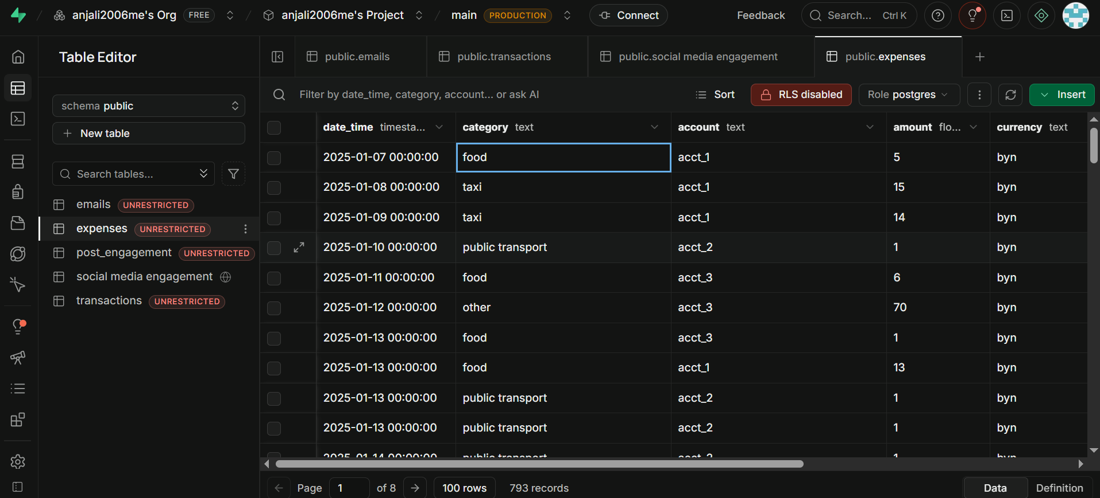

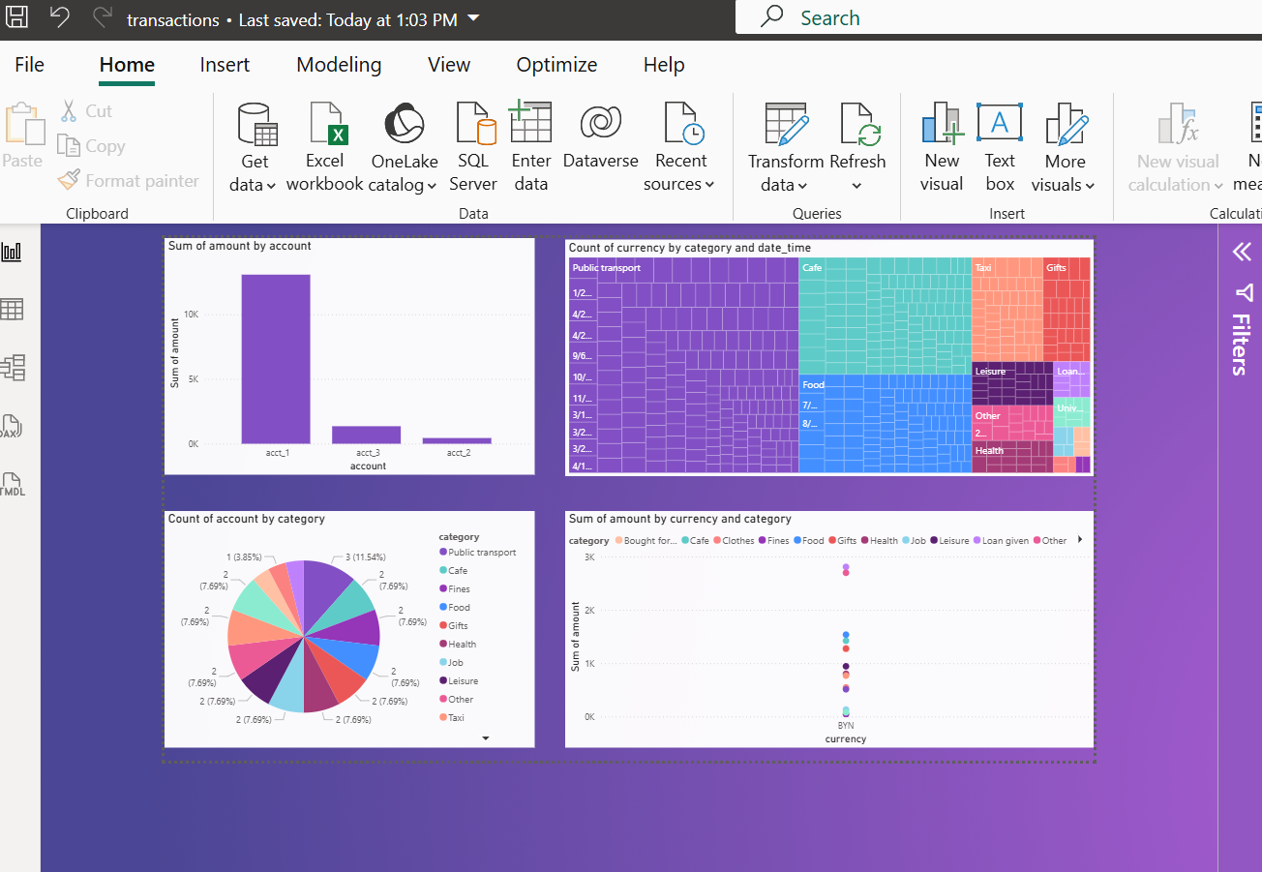
TABLEAU:
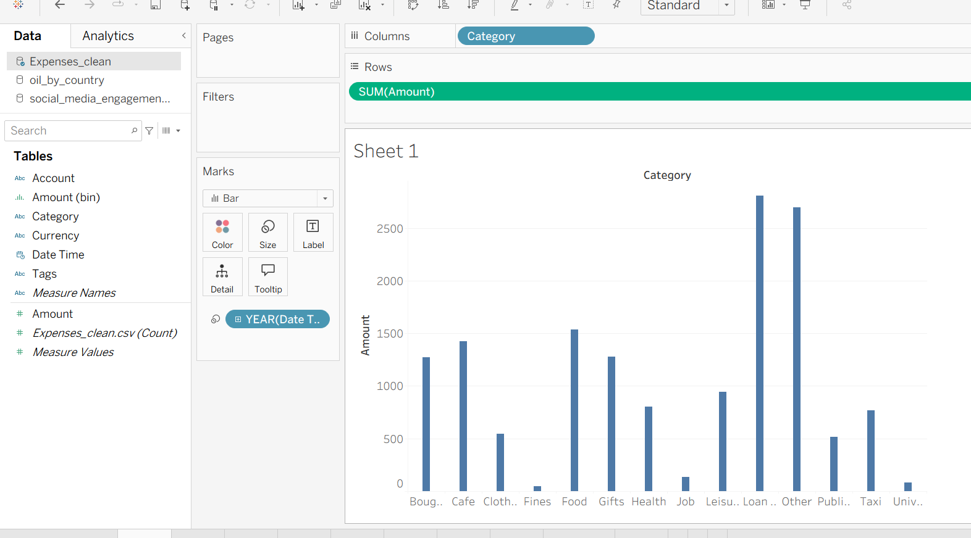

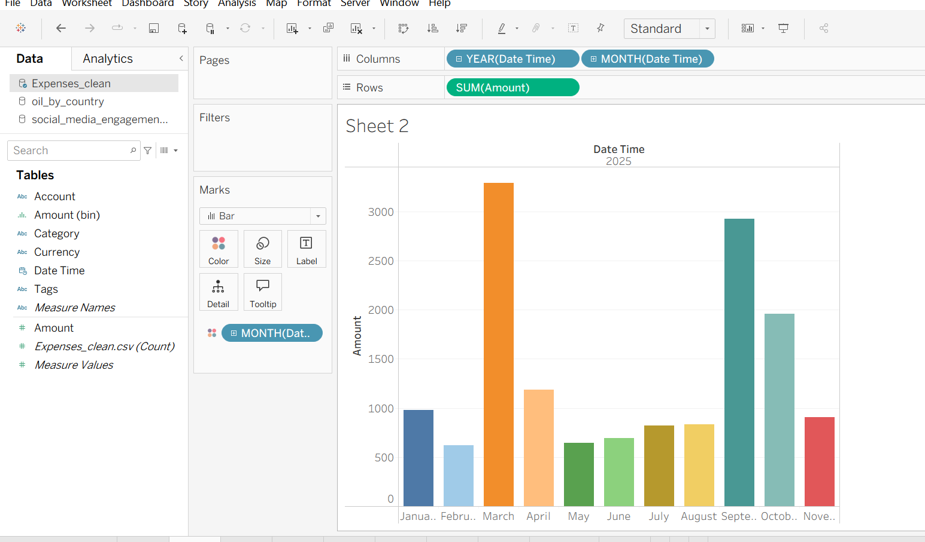

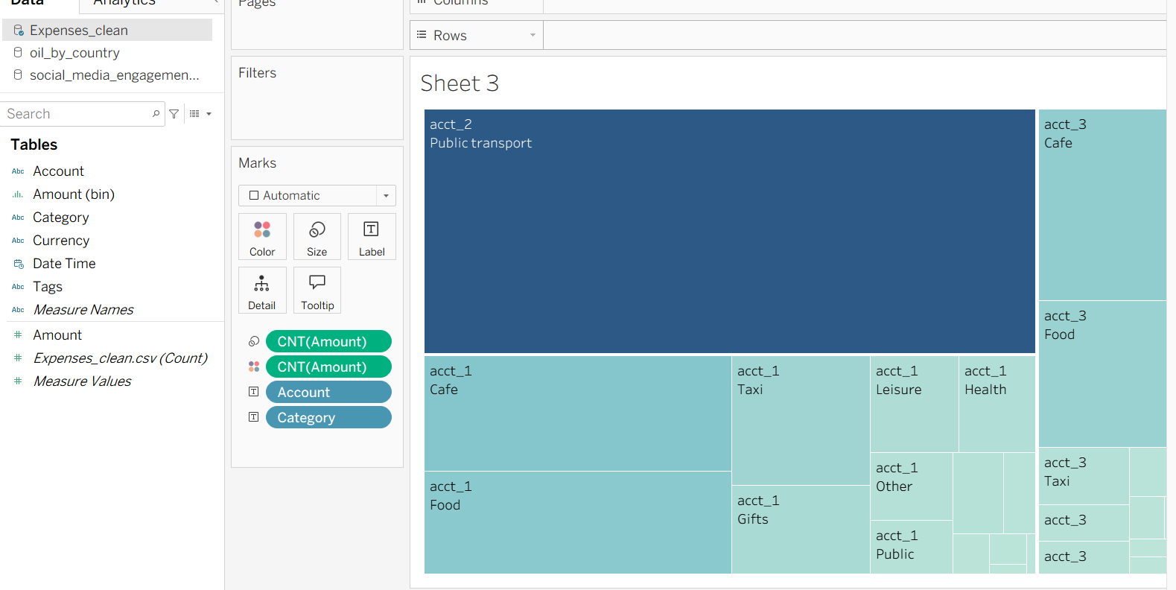

RESULT:

